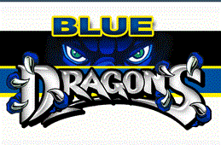

**Chemistry Bev Howe**

**Week 34 April 24 – April 28**

|  |  |  |  |
| --- | --- | --- | --- |
|  | **Monday** | **Tuesday** | | | **Wednesday** | **Thursday** | **Friday** |  |  |
| **Objective(S)**  (wHAT DO i WANT sTUDENTS TO knOW/) | To review Molar Volume, %Comp, Empirical and Molecular Formulas | To check student understanding of molar volume, %Comp, empirical and molecular formulas | | | To write chemical equations in word form.  To balance chemical equations. | To write chemical equations in word form.  To balance chemical equations. | To write chemical equations in word form.  To balance chemical equations. |  |  |
| **InTRUCTIONAL mETHODS**  (hOW AM i GOING TO inSTRUCT/) | Hand back quizzes from Friday and answer any questions.  Review for Test | Answer any questions before the test. | | | Show students using example how to write and balance chemical equations | Check progress with writing and balancing chemical reactions. | Answer questions before Quiz  Show examples for Types of Chemical Reactions |  |  |
| **AsSESSMENT**  How will I assess Learning | Answer student questions in preparation for test. | Test Molar Volume, %Comp and Empirical and Molecular Formulas | | | Worksheet writing and balancing chemical equations | Lab Activity over writing and balancing chemical equations. | Quiz Balancing Chemical Equations |  |  |
| **CLOSURE** | Test Molar Volume, %Comp and Empirical and Molecular Formulas Tuesday |  | | | What are the differences between molecular and ionic compounds | Quiz Balancing Chemical Equations Friday |  |  |  |